CHAPTER 4: Chemical patterns
Worksheet 4.9

Chemical formulae
Student: Class:

Covalent compounds
1. Complete the table by writing the chemical formula of the covalent compound formed from the listed elements.
Element 1 | Element 2 | Formula | Name of compound
Nitrogen | Chlorine |  | Nitrogen trichloride
Sulfur | Oxygen |  | Sulfur trioxide
Carbon | Sulfur |  | Carbon disulfide
Carbon | Oxygen |  | Carbon monoxide
Phosphorus | Oxygen |  | Diphosphorus pentoxide
Carbon | Fluorine |  | Carbon tetrafluoride
Oxygen | Bromine |  | Oxygen dibromide
Nitrogen | Oxygen |  | Dinitrogen tetroxide

Ionic compounds
2. Use the table of valencies in your textbook to complete the table by writing the chemical formula of the ionic compound formed from the listed elements. Name each compound.
Positive ion | Negative ion | Formula | Name of compound
Silver | Iodide
Lead | Sulfide
Calcium | Nitride
Aluminium | Sulfide
Barium | Nitrate
Copper (II) | Sulfate
Sodium | Phosphate
Zinc | Hydrogen carbonate

Structural formulae
3. The structural formulae for various common compounds are shown. Write the molecular formula for each compound.
(a) Lactic acid (b) Butene (c) Hydrazine
 | 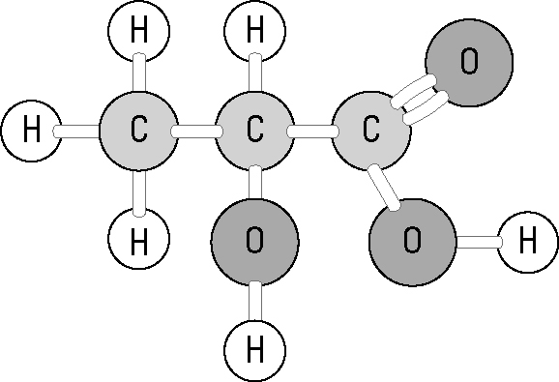 | 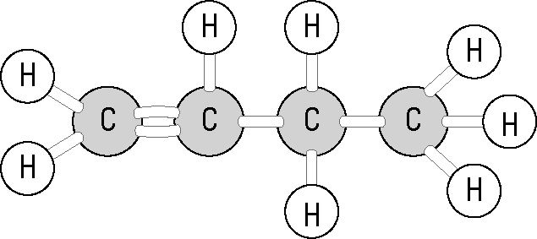 | 
  

